Math Word Problem Solver

Anish Parajuli (071bct503), Prasidha Karki (071bct527), Satyarth Upadhyaya (071bct536), Sudip Bhattarai

(071bct544)

*Abstract*—Descriptive math problems requires understanding the context from the sentences, identifying involved entities or variables, determining relationship between them and using known formula or rules to obtain simpler form or a single solution. Dealing with such problems is not possible without being able to convert the description into mathematical representation using different variables. Math Problem Solver is a AI, Machine Learning based application that helps school level students to from mathematical statement from description and to solve them step wise.

*Keywords*—*Artificial Intelligence, Word problems, NLP, Mathematics.*

# I. INTRODUCTION

Math problems cannot be solved without forming the initial statement based on the given detail in text. Many students fail to solve math problems just because they couldn’t convert the given details into known and unknown variables and relationship between them. Math problem solver helps such students to form initial problem statement in mathematical expression and to reach to the solution of problem step wise.

The computation of mathematical word problems opens a domain of real world solutions. The ability to formalize a word problem in natural language and process it provides a user interface that is easy to learn, operate, and encouraging to use. Currently mathematics software interfaces remain clumsy and non-user-friendly. Even though the provision of a standard protocol and syntax for mathematical input is a remote possibility, users often feel reluctant to learn yet another syntactic convention.

As for children and adults, people are most challenged by word problem solving not because of their mathematical skills but because of text comprehension. Regularly, incorrect answers to word problems are because of correct calculations to incorrect problem representation. Current search engines cannot solve mathematical word problems, if a user wanted to query the solution to a math problem traditional search engines will only return the calculated result. Only returning the result cripples the learning ability of users because he or she is not learning how to solve the problem.

The purpose of this paper is to introduce a fuzzy logic ontology model that is geared to use natural language processing (NLP) to interpret text and to solve mathematical equations, consequently educating users by providing supporting detailed steps of the solution.

# II. LITERATURE REVIEW

Understanding semantics of a natural language text has been the focus of many researchers in natural language processing (NLP). Recent work focus on learning to align text with meaning representations in specific, controlled domains.

A few methods (Zettlemoyer and Collins, 2005; Ge and Mooney, 2006) use an expensive supervision in the form of manually annotated formal representations for every sentence in the training data.

More recent work (Eisenstein et al., 2009; Kate and Mooney, 2007; Goldwasser and Roth, 2011; Poon and Domingos, 2009; Goldwasser et al., 2011; Kushman and Barzilay, 2013) reduce the amount of required supervision in mapping sentences to meaning representations while taking advantage of special properties of the domains.

Our work is also closely related to the grounded language acquisition research (Snyder and Barzilay, 2007; Branavan et al., 2009; Branavan et al.,2012; Vogel and Jurafsky, 2010; Chen et al., 2010;Hajishirzi et al., 2011; Chambers and Jurafsky,2009; Liang et al., 2009; Bordes et al., 2010)where the goal is to align a text into underlying entities and events of an environment. These methods interact with an environment to obtain supervision from the real events and entities in the environment.Our method, on the other hand, grounds the problem into world state transitions by learning to predict verb categories in sentences.

Previous work on studying math word and logic problems uses manually aligned meaning representations or domain knowledge where the semantics for all the words is provided (Lev, 2007; Levet al., 2004). Most recently, Kushman et. al. (2014) introduced an algorithm that learns to align algebra problems to equations through the use of templates. This method applies to broad range of math problems, including multiplication, division,and simultaneous equations, while A RIS only handles arithmetic problems (addition and subtraction).

Wolfram|Alpha a computational software has some features we have purposed for our system. It is an online service that answers factual queries directly by computing the answer from externally sourced "curated data", rather than providing a list of documents or web pages that might contain the answer as a [search engine](https://en.wikipedia.org/wiki/Search_engine) might. Though the software is meant for solving mathematical queries with visualization and stepwise process, It also has feature of answering word questions that require mathematical process to get to an answer.

The software successfully interprets some classes of simple algebraic problems but fails to provide results for similar and very basic questions. It fails for a lot of classes of problems that are descriptive instead of being a mathematical statement.

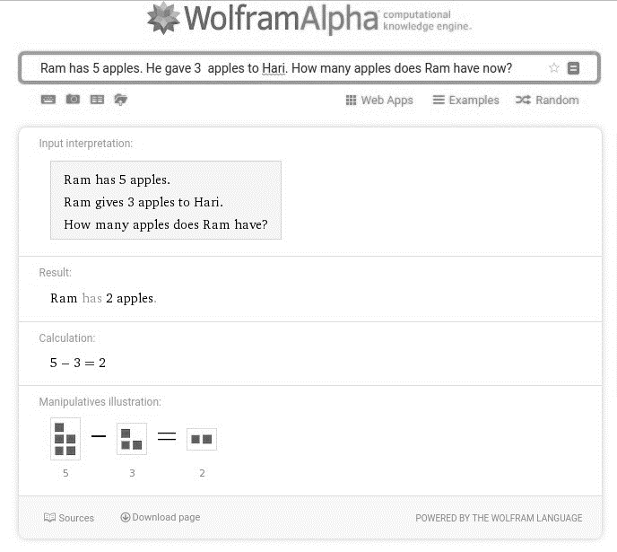

Figure 1 : Simple query to WolframAlpha with it's correct interpretation and output

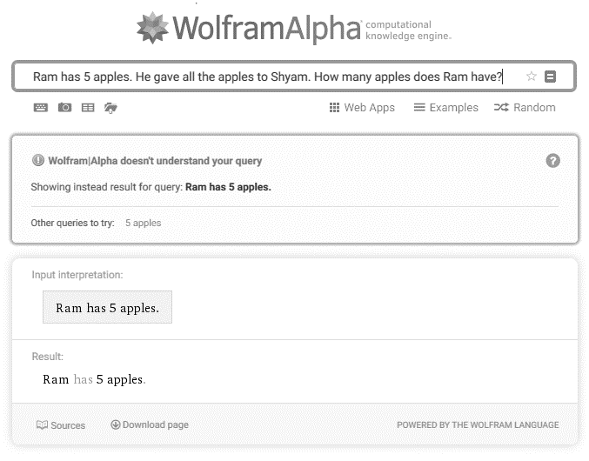

Figure 2: Wolfram|Alpha fails to answer very similar and straigh tforward question like the previous one

III. MEHODOLOGY  *Demonstration of Problem Solving process with a simple question:*

**Ram has 5 apples.**  **He gave 3 apples to Hari. How many apples does he have now?**

1. For each words in a sentence, identify the part of speech of word.(procedures are provided by nltk library)

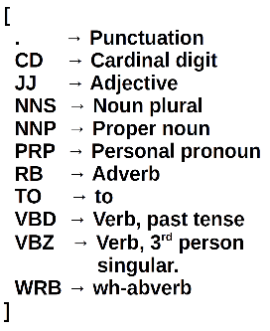

Figure 3 : Abbrevations for nltk word classification

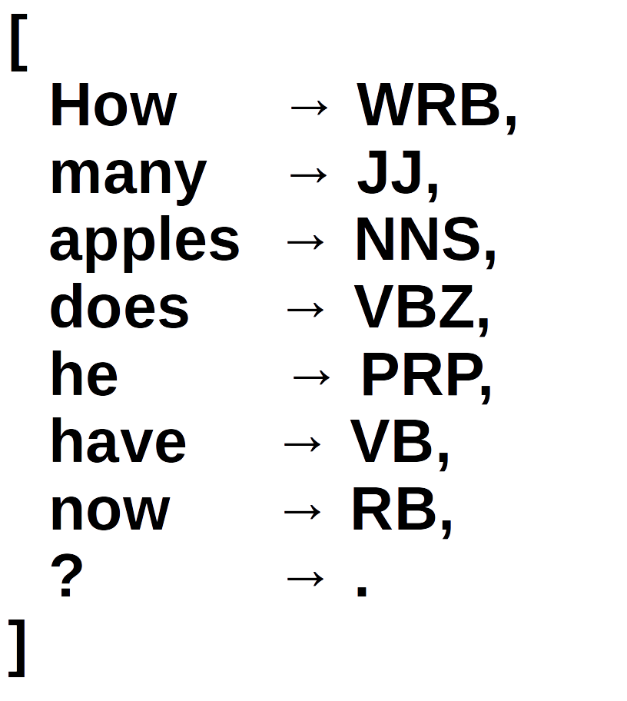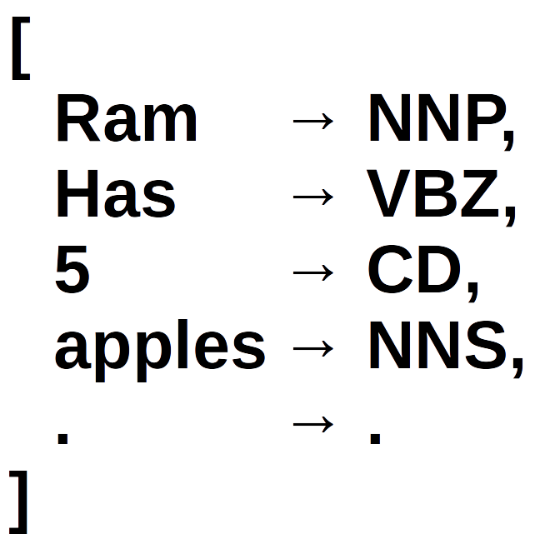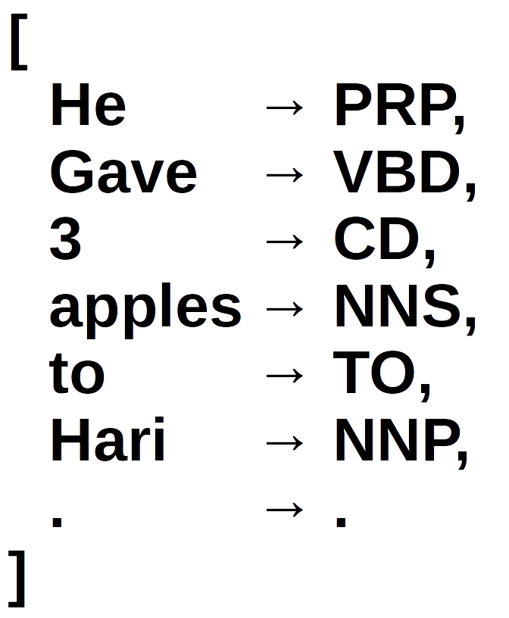

Figure 4 : Tokenization and classification of words

1. Tokenize the sentences such that the tokens are separated by adverbs and verbs.

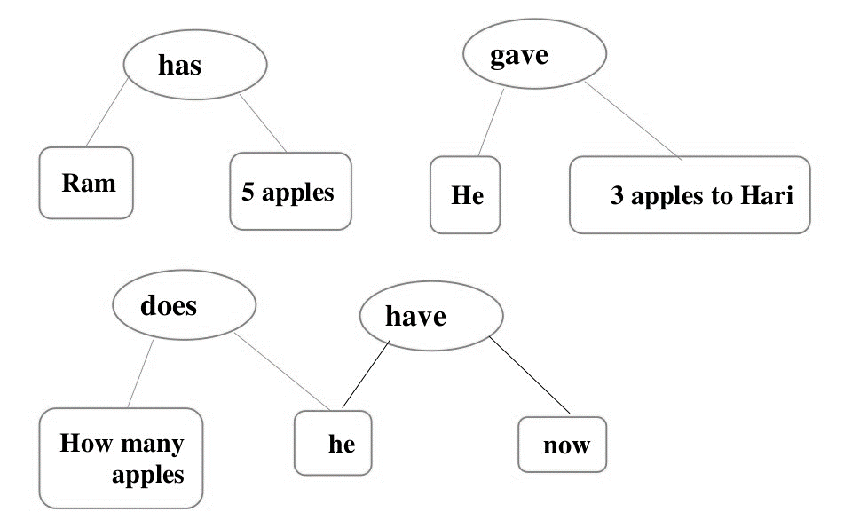

Figure 5 : Words separation using verbs

1. For each tokenized item tokenize them again such they are separated by preposition or conjunction. Now each tokenized part is some active or inactive entity (i.e. noun/pronoun or adjective + noun/pronoun). These entities are represented as nodes of a graph.

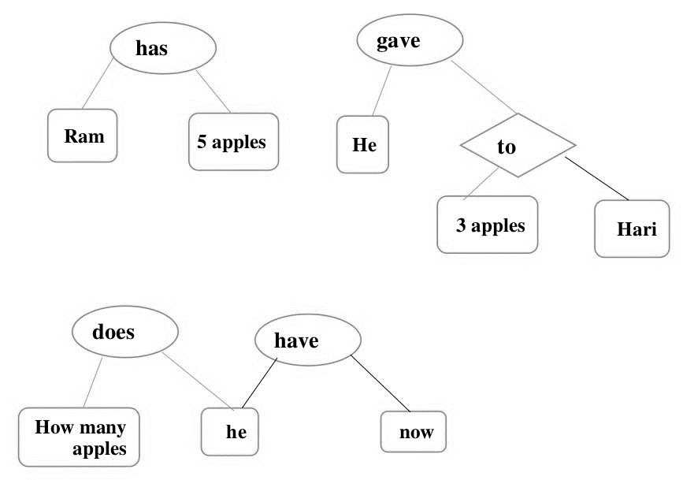

Figure 6 : Noun separation using preposition and conjunction.

1. Convert Pronouns to referenced noun and add attributes to each node based on adjectives used in the sentence.

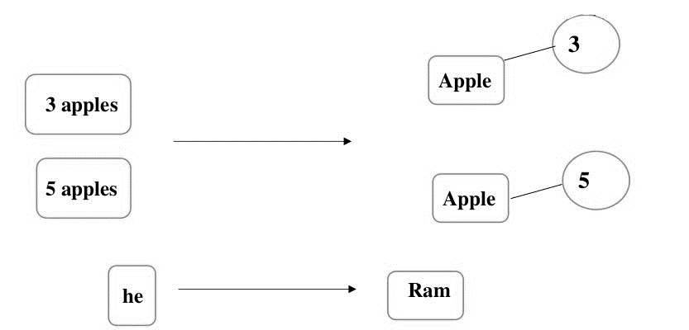

Figure 7 : Assignment of attributes to noun

1. For each interrogative sentences, find out the ‘nouns’ or ‘attributes’ that are asked.

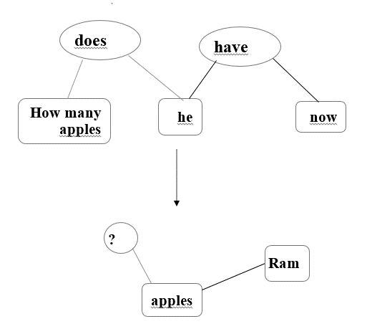

Figure 8 : Determining the unknown variables

1. Establish edge between all the nouns based on verb and preposition.

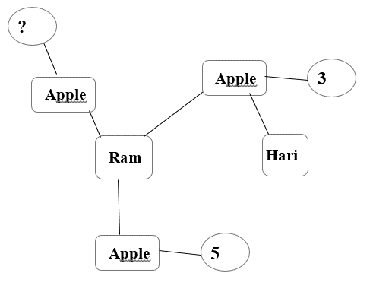

Figure 9 Connection of all the related nouns with their attributes.

1. using the edges in the graph and the attributes of nodes, construct mathematical equations.

Ram.apple[1]=+5

Ram.apple[2]=-3

Ram.apple = +5+(-3)

= +2

# REFERENCES

[1] H. Kopka and P. W. Daly, *A Guide to LATEX*, 3rd ed. Harlow, England: Addison-Wesley, 1999.

A. Bordes, N. Usunier, and J. Weston. 2010. Label ranking under ambiguous supervision for learning semantic correspondences. In Proc. International Conference on Machine Learning (ICML). S. R. K. Branavan, Harr Chen, Luke S. Zettlemoyer, and Regina Barzilay. 2009. Reinforcement learn- ing for mapping instructions to actions. In Proc. of the Annual Meeting of the Association for Com- putational Linguistics and the International Joint Conference on Natural Language Processing of the AFNLP (ACL-AFNLP).

[2] Luke Zettlemoyer and Michael Collins. 2009. Learning context-dependent mappings from sentences to logical form. In *Proceedings of the Joint Conference of the Association for Computational Linguistics and International Joint Conference on Natural Language Processing*.

[3] Luke Zettlemoyer and Michael Collins. 2005. Learning to map sentences to logical form: Structured classification with probabilistic categorial grammars. In *Proceedings of the Conference on Uncertainty in Artificial Intelligence*.

[4] Tom Kwiatkowski, Eunsol Choi, Yoav Artzi, and Luke Zettlemoyer. 2013.

Scaling semantic parsers with on-the-fly ontology matching. In *Proceedings*

*of Empirical Methods in Natural Language Processing*